**Experiment No: 9**

**Title**: Implement Infrastructure as a Service using Open stack.

**Aim**: To study IAAS(Infrastructure as a Service) and implement it using Openstack.

**Theory:**

**Openstack:**

OpenStack is an open-source platform that uses pooled virtual resources to build and manage private and public clouds. The tools that comprise the OpenStack platform, called "projects," handle the core cloud-computing services of compute, networking, storage, identity, and image services. More than a dozen optional projects can also be bundled together to create unique, deployable clouds.

In virtualization, resources such as storage, CPU, and RAM are abstracted from a variety of vendor-specific programs and split by a hypervisor before being distributed as needed. OpenStack uses a consistent set of application programming interfaces (APIs) to abstract those virtual resources 1 step further into discrete pools used to power standard cloud computing tools that administrators and users interact with directly.

OpenStack and virtualization management platforms both sit on top of virtualized resources and can discover, report, and automate processes in vendor-disparate environments.

But while virtualization management platforms make it easier to manipulate the features and functions of virtual resources, OpenStack actually uses the virtual resources to run a combination of tools. These tools create a cloud environment that meets the National Institute of Standards and Technology's 5 criteria of cloud computing: a network, pooled resources, a user interface, provisioning capabilities, and automatic resource control/allocation.

**OpenStack computing components**  
OpenStack has a modular architecture that controls large pools of compute, storage and networking resources.  
**Compute (Nova):** OpenStack Compute (Nova) is the fabric controller, a major component of Infrastructure as a Service (IaaS), and has been developed to manage and automate pools of computer resources. It works in association with a range of virtualisation technologies. It is written in Python and uses many external libraries such as Eventlet, Kombu and SQLAlchemy.

**Object storage (Swift):** It is a scalable redundant storage system, using which objects and files are placed on multiple disks throughout servers in the data centre, with the OpenStack software responsible for ensuring data replication and integrity across the cluster. OpenStack Swift replicates the content from other active nodes to new locations in the cluster in case of server or disk failure.

**Block storage (Cinder):** OpenStack block storage (Cinder) is used to incorporate continual block-level storage devices for usage with OpenStack compute instances. The block storage system of OpenStack is used to manage the creation, mounting and unmounting of the block devices to servers. Block storage is integrated for performance-aware scenarios including database storage, expandable file systems or providing a server with access to raw block level storage. Snapshot management in OpenStack provides the authoritative functions and modules for the back-up of data on block storage volumes. The snapshots can be restored and used again to create a new block storage volume.  
**Networking (Neutron):** Formerly known as Quantum, Neutron is a specialised component of OpenStack for managing networks as well as network IP addresses. OpenStack networking makes sure that the network does not face bottlenecks or any complexity issues in cloud deployment. It provides the users continuous self-service capabilities in the networks infrastructure. The floating IP addresses allow traffic to be dynamically routed again to any resources in the IT infrastructure, and therefore the users can redirect traffic during maintenance or in case of any failure. Cloud users can create their own networks and control traffic along with the connection of servers and devices to one or more networks. With this component, OpenStack delivers the extension framework that can be implemented for managing additional network services including intrusion detection systems (IDS), load balancing, firewalls, virtual private networks (VPN) and many others.

**Infrastructure as-a-service (IaaS)**  
IaaS includes the delivery of computing infrastructure such as a virtual machine, disk image library, raw block storage, object storage, firewalls, load balancers, IP addresses, virtual local area networks and other features on-demand from a large pool of resources installed in data centres. Cloud providers bill for the IaaS services on a utility computing basis; the cost is based on the amount of resources allocated and consumed.

**Dashboard (Horizon):** The OpenStack dashboard (Horizon) provides the GUI (Graphical User Interface) for the access, provision and automation of cloud-based resources. It embeds various third party products and services including advance monitoring, billing and various management tools.

**Identity services (Keystone):** Keystone provides a central directory of the users, which is mapped to the OpenStack services they are allowed to access. It refers and acts as the centralised authentication system across the cloud operating system and can be integrated with directory services like LDAP. Keystone supports various authentication types including classical username and password credentials, token-based systems and other log-in management systems.

**Image services (Glance):** OpenStack Image Service (Glance) integrates the registration, discovery and delivery services for disk and server images. These stored images can be used as templates. It can also be used to store and catalogue an unlimited number of backups. Glance can store disk and server images in different types and varieties of back-ends, including Object Storage.

**Telemetry (Ceilometer):** OpenStack telemetry services (Ceilometer) include a single point of contact for the billing systems. These provide all the counters needed to integrate customer billing across all current and future OpenStack components.

**Orchestration (Heat):** Heat organises a number of cloud applications using templates with the help of the OpenStack-native REST API and a CloudFormation-compatible Query API.

**Database (Trove):** Trove is used as database-as-a-service (DaaS), which integrates and provisions relational and non-relational database engines.

**Elastic Map Reduce (Sahara):** Sahara is the specialised service that enables data processing on OpenStack-managed resources, including the processing with Apache Hadoop.

**Practical:**

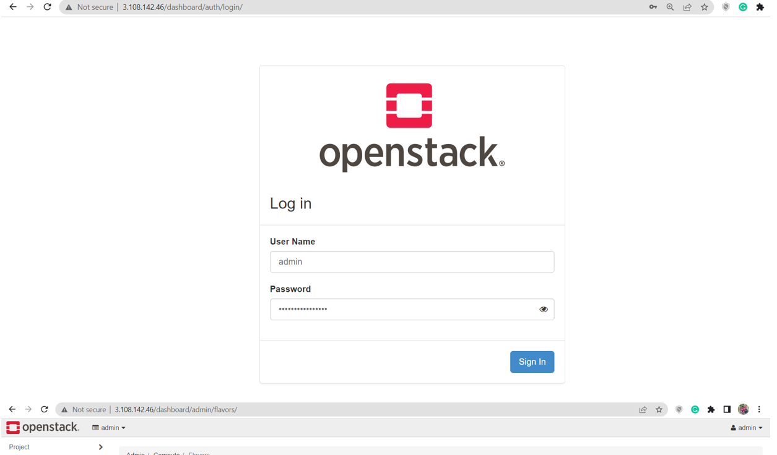

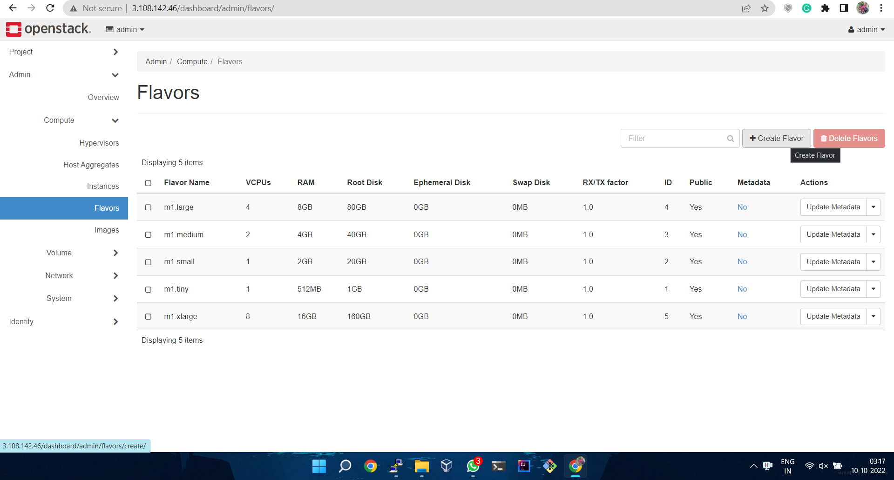

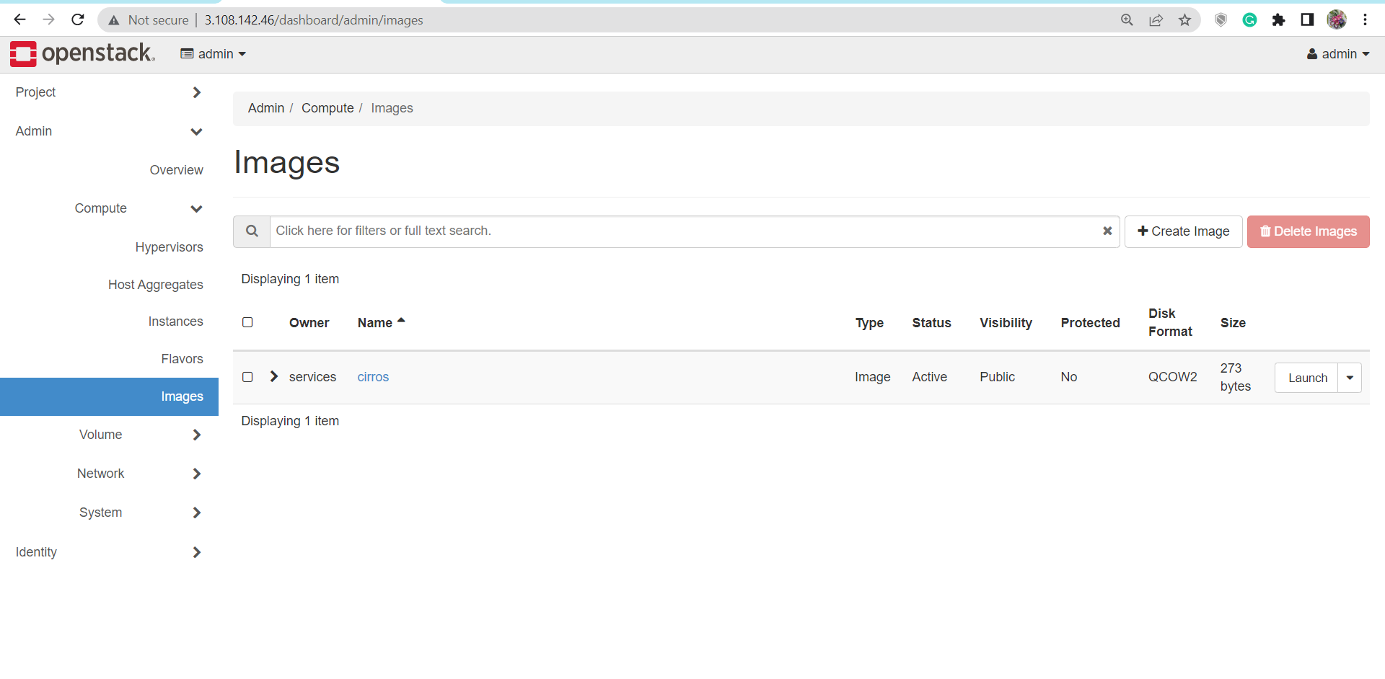

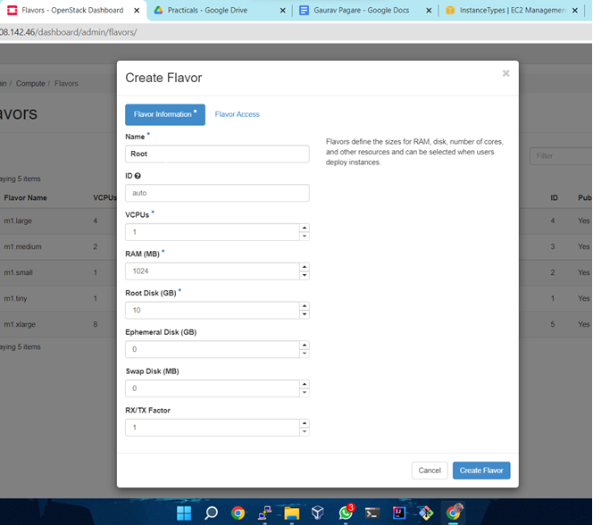

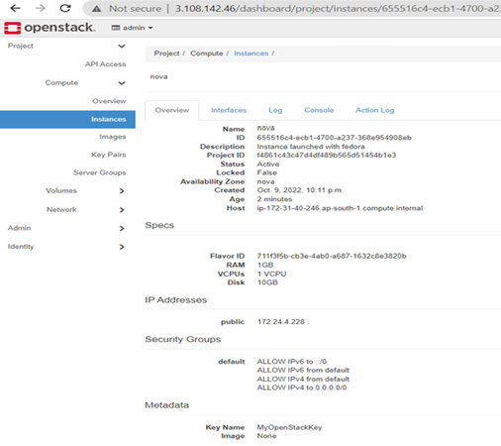

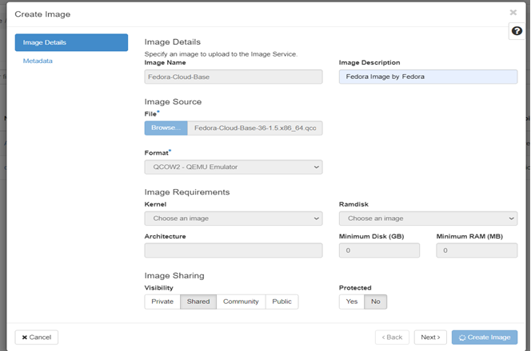

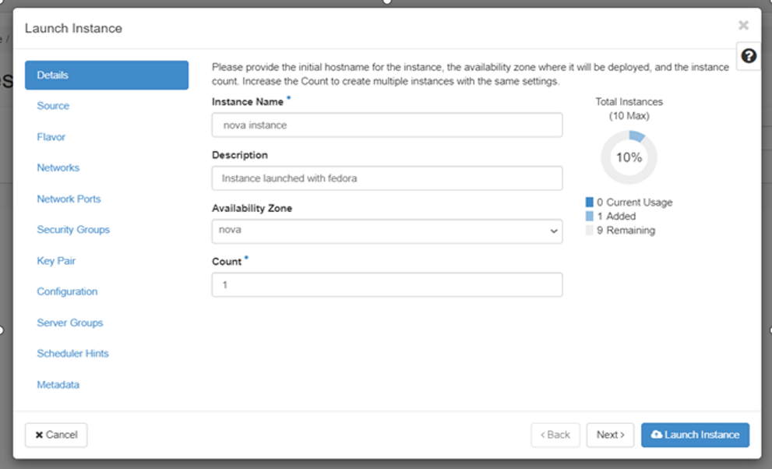

**Conclusion:**

Thus, I have implemented Infrastructure as a Service using Open stack